Day 2 assignment(Git):

Assignment1(git commit):

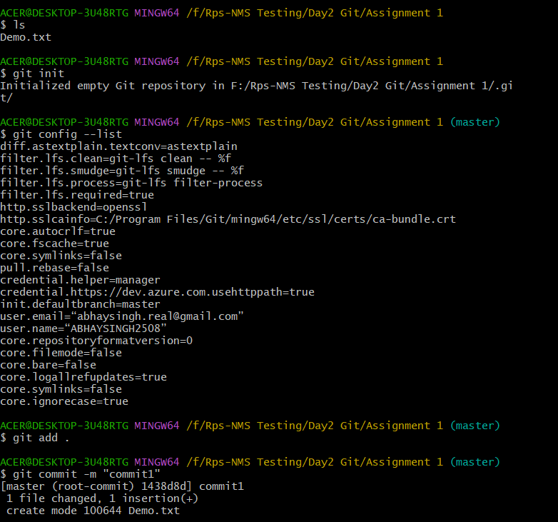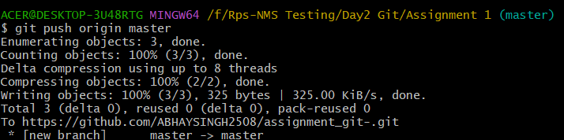

Assignment 2 - branch creation:-

